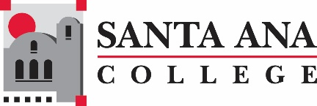

Distance Education Advisory Group Meeting

February 27, 2019

8:00am – 9:30am

SAC, A-101

**Distance Education Mission Statement:**

Our mission in Distance Education at Santa Ana College is to provide our students and faculty with the highest quality distance education program.  We accomplish this mission by assuring that our student coursework provides the depth and breadth of a quality post-secondary degree education while insuring the use of leading edge technology and excellence in teaching.

Agenda

1. CVC-OEI -   
   * Roadmap
   * Site update
   * Current Course Status
   * Tools
     + Interested virtual office hours or group work using Pronto?
   * More FT online faculty – expand this semester outside of Online Degree Pathway courses
2. Online  Library Research – Finding Articles (Jaki)
3. DE Certification Policy –Review Update
4. DE Shirt (optional order with Nancy) and OER T-shirt (pickup)
5. Next Meeting: March 20, 2019

***Santa Ana College Mission Statement:****Santa Ana College inspires, transforms, and empowers a diverse community of learners*.